Quantified Student
Data visualisation
Thijmen Brand (480490)
Stijn Verhagen (440330)



Table of Contents
Table of Contents 2
Version History 3
1. Overview 4
1.1 Preface 4
1.2 Information stakeholder 5
1.3 Requirements (MOSCOW) 6
2. Research 7
2.1 Relevant information 7
2.2 New data points 11
2.3 Canvas API 12
2.4 Graphs 13
2.5 Design 16
2.5.1 User experience 16
2.5.2 Wireframe 16
Conclusion 16
3. Retro’s 18
3.1 Retrospective tools design. 18
3.2 Conclusion 18
4. Result 19
4 KPI’s 20

Version History
Date | Version | Author | Comment
13-09-2022 | 1 | Thijmen Brand, Stijn Verhagen | Document set-up
16-09-2022 | 1.1 | Thijmen Brand, Stijn Verhagen | Overview, Research
23-09-2022 | 1.2 | Thijmen Brand, Stijn Verhagen | Process survey answers
04-10-2022 | 1.3 | Thijmen Brand, Stijn Verhagen | Canvas API research, Graph Typedefs

1. Overview

1.1 Preface
Quantified student is a student dashboard where students can visualise their study performance. They can compare this data to other data sources to discover patterns in the way they study and how they can improve on that. This document is to learn what data sources are valuable for the student and how we can visualise this data.

Assignment
For this assignment we are developing a dashboard in which a student can see his study performance in contrast to other factors that could have an influence on it.

What’s it for?
This visualisation of different relevant data points can help the student get better grades and improve his overall study score.

Team

Thijmen Brand Stijn Verhagen

1.2 Information stakeholder

Eric Slaats

Eric Slaats is a man, father, partner, eager to learn, enthusiastic, spontaneous, musical, musician, guitarist and he also teaches at Fontys Hogeschool ICT. He writes books and is currently researching the behaviour of neural networks in a financial environment. Eric is inspiring and innovative and therefore fits well with the first edition of TEDxVeghel. He is always looking for the next innovation, the next step in the educational field. Enthusiastic looking for reinforcement, nationally, internationally and always looking for distinctive ways to improve education.

1.3 Personal goal - Thijmen
With this document I want to gain insights in how students think about their own performance and how that would be measurable. Then I want to think about how we can visualise this data in a structured and ordered way in which every student can see the insights that they value the most.

1.4 Requirements (MOSCOW)
The checks visualise the completion of the requirements.

Must have
- As a student I want a dashboard that visualises data in a way I can set up. | ✅
- As a student I want to easily adjust my dashboard to see information I think is relevant.
- As a student I want to be able to combine important data points in one graph.
- As a student I want to see my Canvas course progression.
- As a student I want to see how much time I have spent inside my course.
- As a student I want to see what impact attendance has on my grade.
- As a student I want to be able to see upcoming deadlines.

Should have
- As a Fontys student I want to see my newest grade in contrast to my overall average grade

Could have
- As a Fontys student I want to be able to see my feed pulse data | -

Won’t have
-

2. Research

2.1 Relevant information
In order to gather relevant information about what data should be visualised and how we should present it in the dashboard, we sent out an enquete. This enquete is distributed to students who are currently studying at different educational institutions.
The first thing we wanted to know was whether students thought a performance dashboard was useful at all. The results show that 57% of the respondents answered yes to this question and another 35% said maybe. These answers are enough to even start the project.
Before we sent out the form, we already had some factors that could have an impact on study performance, and we first wanted to test whether people agreed with the factors we defined. The results are as follows;

(Answers are on a set scale from 1 with least influential to 5 most influential)
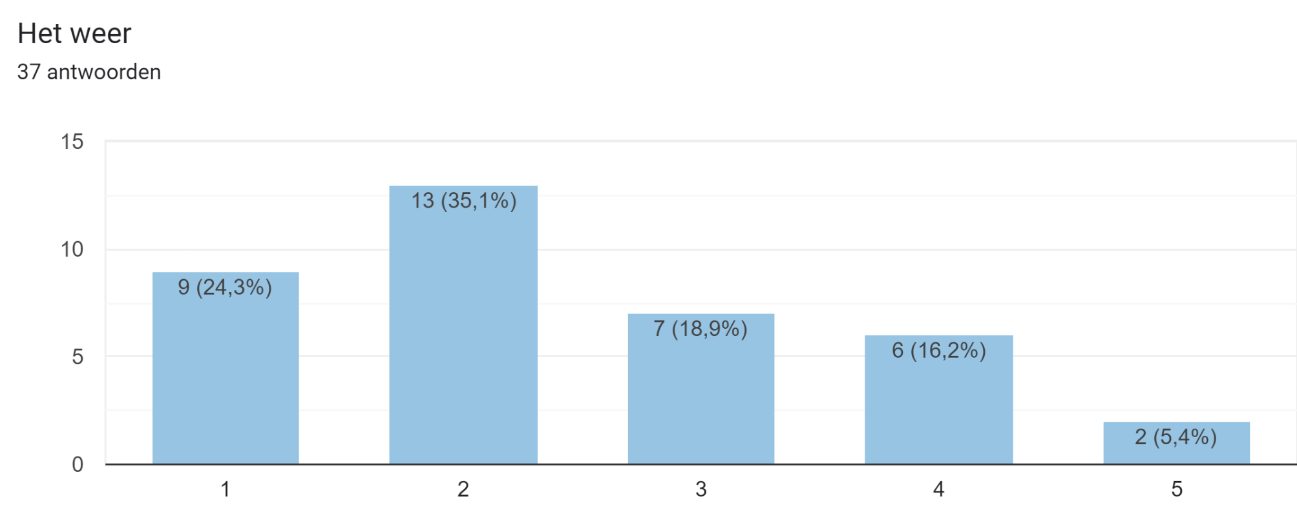
The main reason people found weather less influential on their study performance was that they just didn’t care for two reasons, or they were most of the time inside and the weather didn’t bother them, or they had to travel either way and just took it for granted.

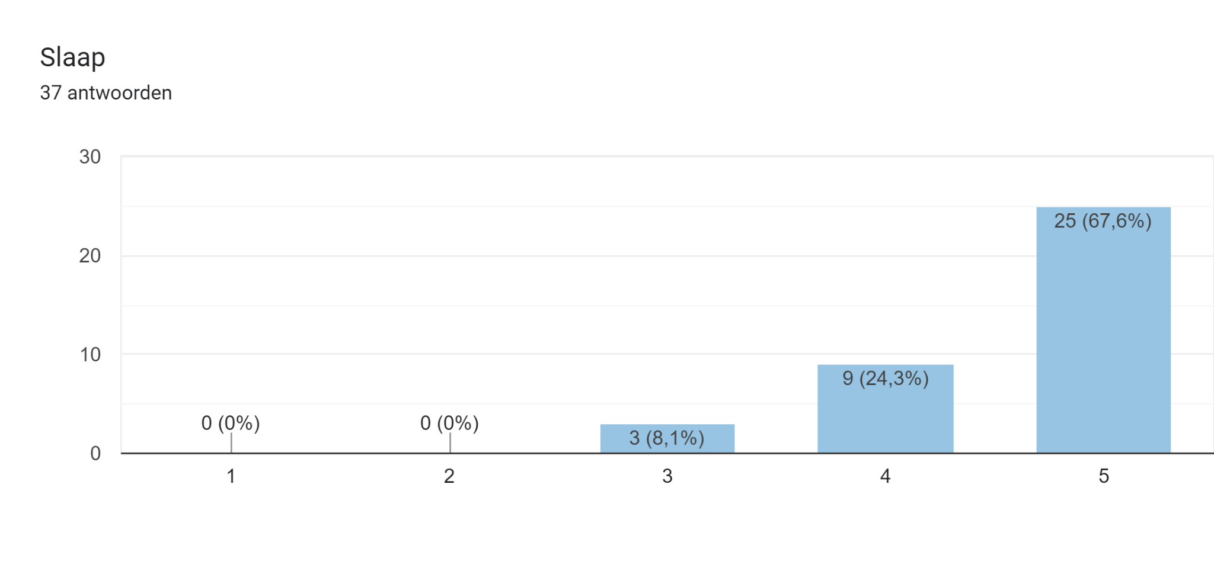
Sleep appears to be one of the most important factors for study motivation. Students mostly feel like they are lousy and without energy when they don’t sleep well.
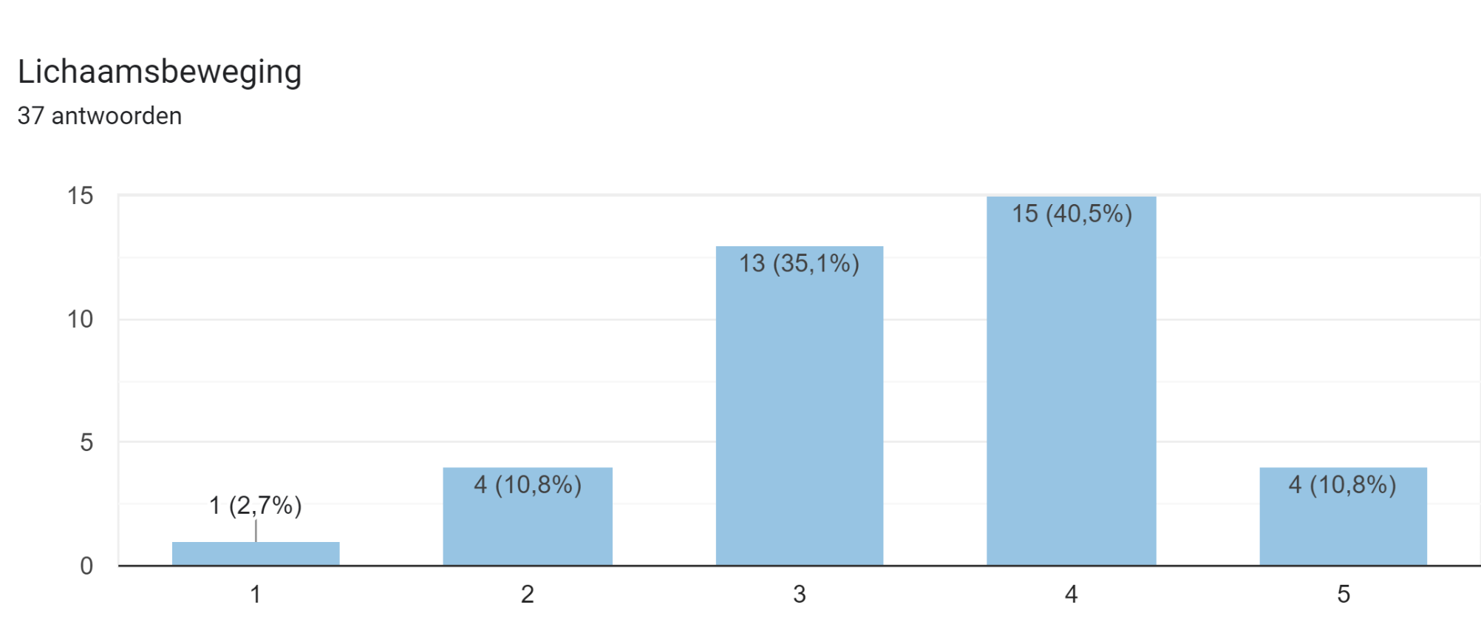
Physical activity makes students more relaxed, focused and alert, which has a positive effect on learning performance.
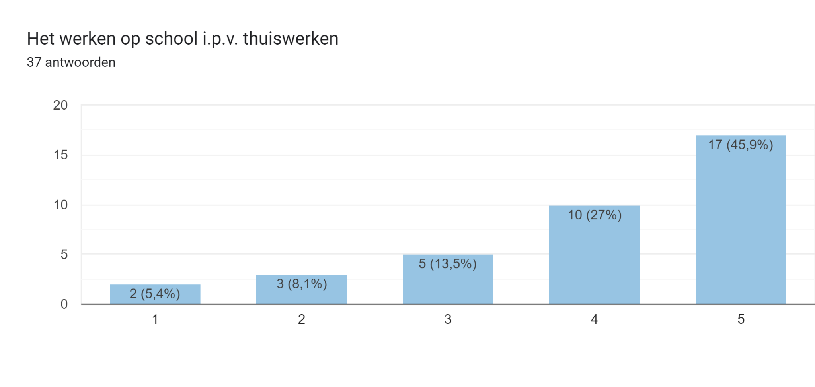
Working on site also seems to be an important factor for the students. They feel more motivated to work / learn on projects and get more done. The main reason for this is that students feel that they have to accomplish something when they work on campus.

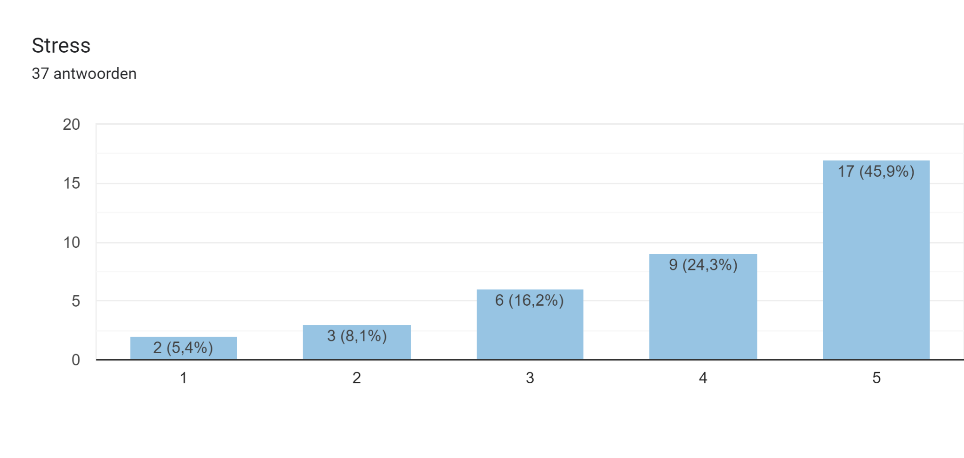
Students who are under stress seem to work either more or less, the answers vary. Some students feel more motivated and can achieve more when they work under stress, while others feel demotivated and start procrastinating under stress. Either way, they believe it has a big impact on their motivation at school.
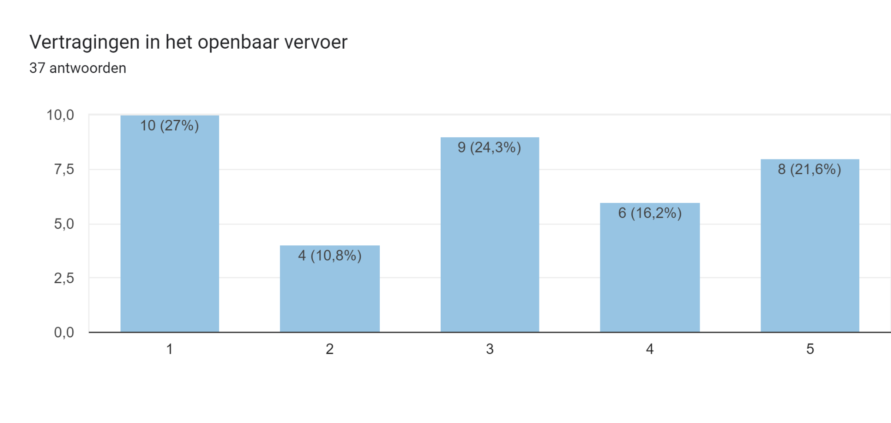Public transport seems to be very distributed among the respondents. This can be explained by the fact that not all students use public transport and use other alternatives such as the bicycle or the car. However, those who do use public transport say that it can have quite an impact when, for example, trains do not arrive on time or public transport goes on strike again.

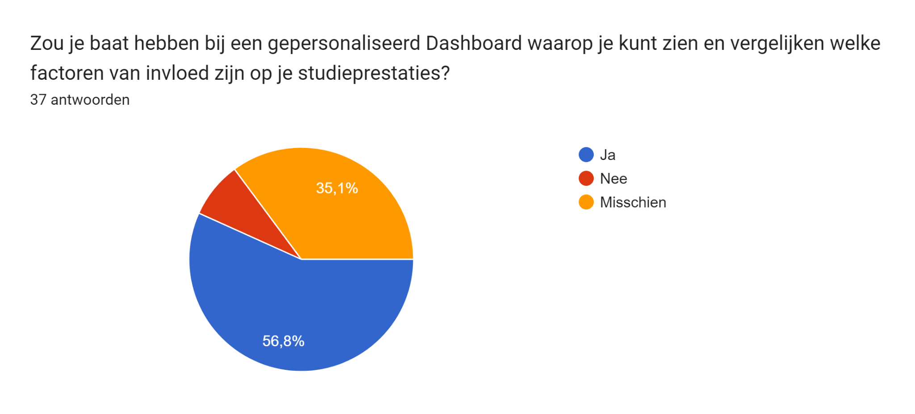
Most students think that a student motivation dashboard is useful for their personal development. 35.1% of the students do not know if the dashboard will help them in any way. This could be related to the fact that they do not know exactly what data will be included in the dashboard.

2.2 New data points
The survey consisted of some confirmations of the data points already defined. But we also wanted to see if students had other factors that they thought had an impact on their academic performance. The students surveyed brought in a lot of different points that we hadn't thought of yet, however not all of these factors were measurable for us. We selected four new factors that we found interesting to include in the performance dashboard, namely:
- Workload
- Physical activity
- Lesson times
- Screen time

But these points are not measurable in an easily visualised way. Some of this data is also not accessible for us to collect.

2.3 Canvas API
We have analysed the Canvas Api endpoints to discover possible new data points that we could use and from which we could gain new insights. In doing so, we concluded that there are no new useful endpoints that could be used for the purpose described above.

2.4 Graphs

Naam & doel grafiek | Voorbeeld grafiek | Datamodel
Grade grafiek | 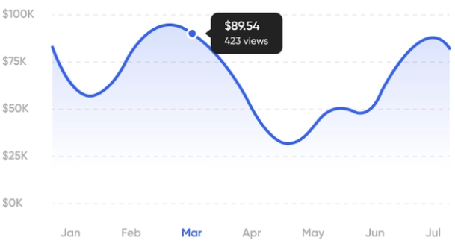 | Y: Grade 1 - 10  X: Total amount of grades
Gehaalde grade afzetten tegen average grade | 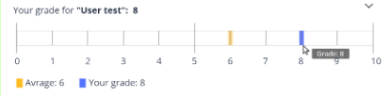 | Percentage totaal  Vs  Percentage laatst gehaalde grade
Ongoing course (hoeveel je hebt gesubmit van het totaal) | 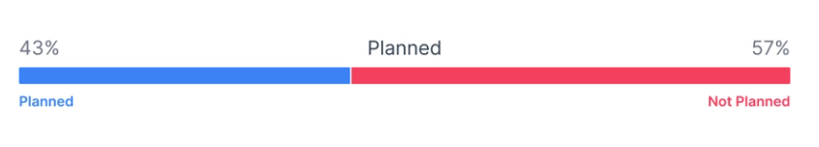 | Modules without submission  Vs  Modules that have a submission
Time spent op school (grafiek of percentage)  Time spent op school VS weer (temp / neerslag) | 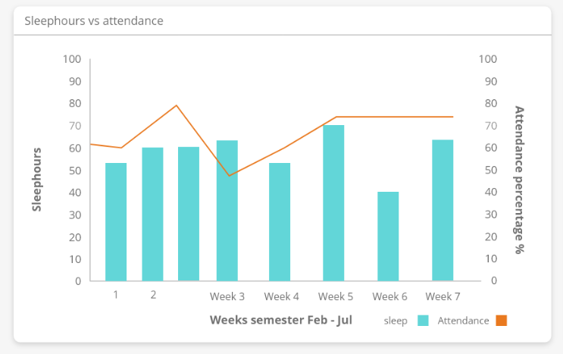  With toggles to toggle different data sources | X: Days in the week  Y: Hours spent on location
Weekly spent hours (in de course) | 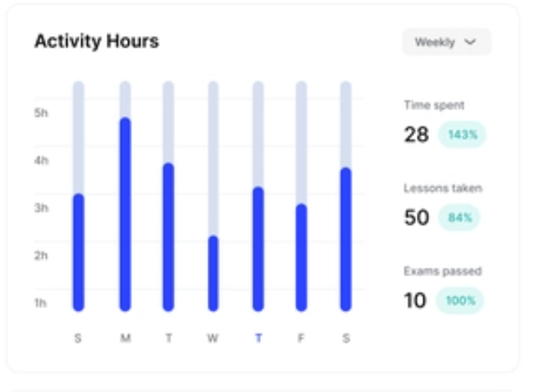 | Y: Total hours spent in course  X: The 7 days of the week
Upcoming deadlines | 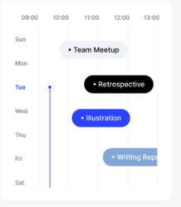 | Y: Days Mo t/m Fr  X: Badge with deliverable and submission time  Example:  Mon - Drone delivery  Tue -  Wed - Competence doc  Thu -  Fri -
Due date VS grades | 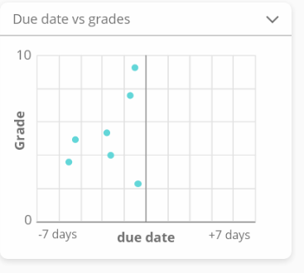 | X: Due date  Y: Grade 1 - 10
Canvas activity | 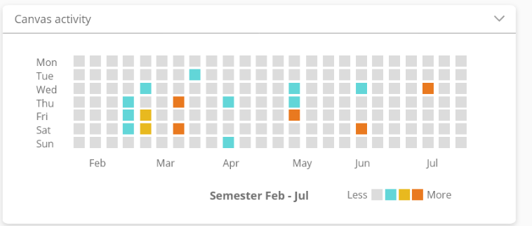 | X: Months  Y: Days of the week  Each tile has a heatmap where the user can see how much activity there was in Canvas.
Activity (steps) |  | X: months  Y: days of the week
Sleep (hours) VS All Canvas  The user can choose which Canvas data. | 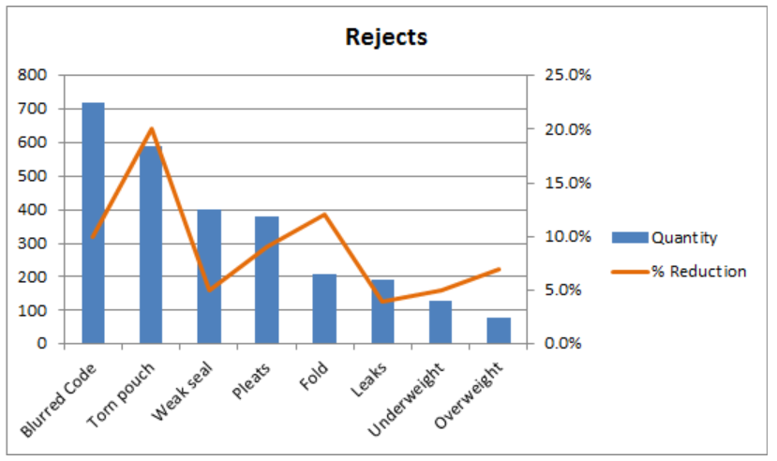 | X: Days of the week  Y1: Time in bed  Y2: Canvas data
Activity (steps) VS All Canvas  The user can choose which Canvas data |  | X: Days of the week  Y1: Active time  Y2: canvas data

2.5 Design

2.5.1 User experience
There are a lot of data points the user can draw conclusions from and not every user finds the same data relevant. So in order to make the dashboard work for everyone it has to be customisable to a student's needs.
To realise this extent of customizability we have come up with a few requirements.
- As a user I want to be able to add and remove data points from my dashboard.
- As a user I want to be able to rescale data points that I think are more or less relevant.
- As a user I want to be able to rearrange date data points on my dashboard.
- As a user I want to be able to define what performance it is.

2.5.2 Wireframe

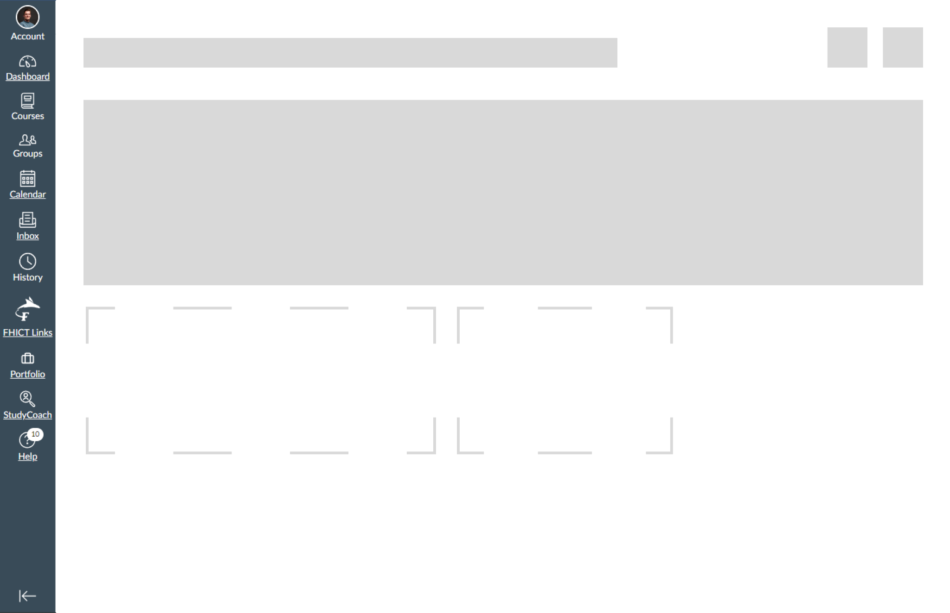

3. Result
In this document we wanted to discover what different data sources are valuable to a student in a way they can improve their study performance. In order to do this we have surveyed different students from different study institutions. We have come up with a few different data sources and tested the validity of them in our survey. We also asked the student what data could be valuable for them to gain new insights we possibly didn’t think of. The results of this survey have been analysed and worked out in chapter 2.1. After this we have thought of how we could visualise this data in graphs. This can be found in chapter 2.4

